What Is the Cumulative Distribution Function?
The cumulative distribution function is used to describe the probability distribution of random variables. It can be used to describe the probability for a discrete, continuous or mixed variable. It is obtained by summing up the probability density function and getting the cumulative probability for a random variable.
The Probability Density Function is a function that gives us the probability distribution of a random variable for any value of it. To get the probability distribution at a point, you only have to solve the probability density function for that point.
The cumulative distribution function of a random variable to be calculated at a point x is represented as Fx(X). It is the probability that the random variable X will take a value less than or equal to x.
Consider the diagram shown below. The diagram shows the probability density function f(x), which gives us a rectangle between the points (a, b) when plotted. f(x) has a value of 1/(b-a).
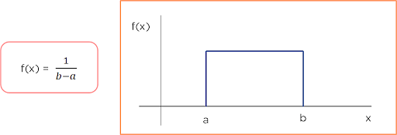
Figure 1: Probability Density Function
Now consider a point c on the x-axis. This is the point you need to find the cumulative distribution function at. According to the definition, you need to find the total probability density function up to point c. This means that you have to find the area of the rectangle between points a and c.
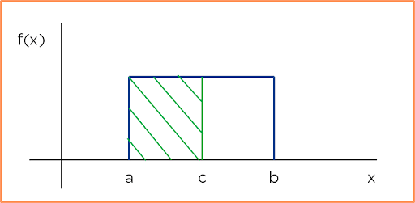
Figure 2: Calculating the CDF
You can do this by multiplying the length and breadth of the rectangle. The breadth is the distance between a and c obtained by subtracting them, and the length is the probability density function. In the end, you get the CDF as:
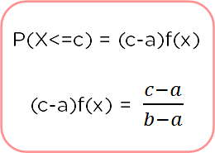
Figure 3: CDF
Since the cumulative distribution function is the total probability density function up to a certain point x, it can be represented as the probability that the random variable X is less than or equal to x.

Figure 4: CDF representation
As you need to get the total PDF sum between two points, you can also represent the CDF as the integration of PDF between the points it has been calculated at. The formula depicted below shows the cumulative distribution function calculated between points (a, b) for the PDF Fx(x).
Figure 5: CDF as the integration of PDF

Understanding the Cumulative Distribution Function With the IRIS Dataset
In this case study, you will be looking at the Iris dataset, which contains information on the sepal length, sepal width, petal length, and petal width of three different species of Iris:
- Iris Setosa
- Iris Versicolor
- Iris Virginica
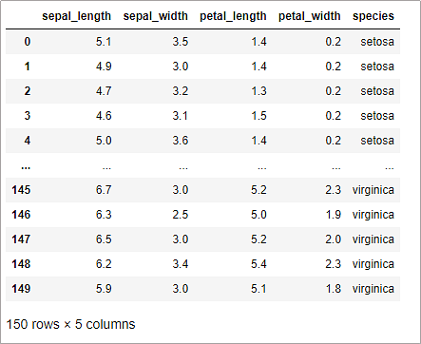
Figure 6: Iris Dataset
All the values are in centimeters. The dataset contains 50 data points on each of the different species. You need to find a reliable measure using which we can differentiate the different species from each other.
Now, plot each feature of our dataset using a bar graph. You plot the features with different colors for each flower to see how they overlap with each other. This is a way of finding the PDF of the data.
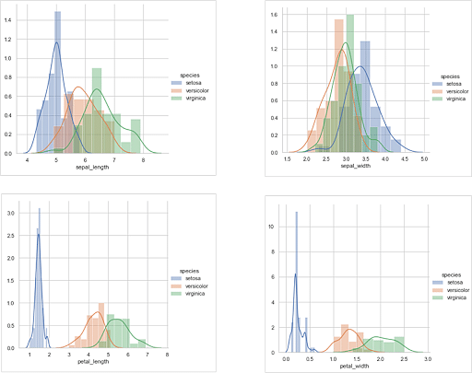
Figure 7: Iris Dataset PDF
The above graphs are as follows from top left to bottom right:
- Sepal_length: In this graph, we can see that the sepal lengths of all three species have considerable overlap. Hence it becomes tough to set parameters or ranges which you can use to differentiate our flowers.
- Sepal_width: This graph has even more overlap. It is also not a feature that you can use to differentiate between our flowers correctly.
- Petal_length: This graph has way less overlap than the other two. The boundaries for Setosa have no overlap with any other species, and Versicolor and Virginica have a slight overlap. You can easily find the different ranges that most of the petal lengths fall into for different species.
- Petal_width: This graph has significantly less overlap than the sepal parameters, but you can see a little bit of overlap between Setosa, Versicolor and Virginica.
Hence, you can conclude that the petal length is the best parameter for differentiating between iris species.
Next, add the PDF and plot the resultant graph to see the CDF for our iris data.
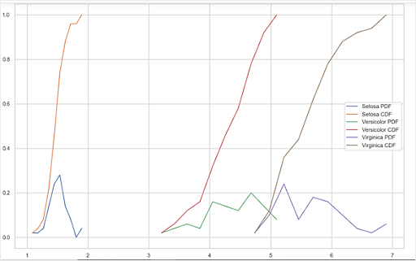
Figure 8: Iris Dataset PDF and CDF
From the above graph, you can notice three things:
- Petal Length < 1.9 is most definitely ‘Setosa’. You can say this as the petal length for setosa falls in this range and does not coincide with the petal length of Versicolor or Virginica.
- 3.2 < Petal length < 5 has a 95% chance of being Versicolor. Versicolor and Virginia have a slight overlap between 4.7 and 5. Hence, any machine learning model may mistake the two, but the chances of that happening are very low.
- Petal length > 5 has a 90% chance of being ‘Virginia’. Again, there is a slight overlap between Versicolor and virginica in the 5-5.2 cm region, which is the cause of the slight error.

Cumulative frequency is a statistical concept that represents the running total of frequencies up to a certain point in a dataset. It is often used in the context of frequency distributions. Here's a breakdown:
1. **Frequency:** In statistics, frequency refers to the number of times a particular value or range of values occurs in a dataset.
2. **Cumulative Frequency:** Cumulative frequency is the sum of the frequencies up to a certain point. It gives you the total number of observations that fall below or equal to a particular value in a dataset.
For example, let's consider a dataset of exam scores:
70, 80, 85, 90, 75, 80, 95, 88, 92
Now, calculate the cumulative frequency:
- For the value 70: Cumulative frequency = 1 (there is one value less than or equal to 70).
- For the value 80: Cumulative frequency = 3 (1 from 70 + 2 from 80).
- For the value 85: Cumulative frequency = 4 (1 from 70 + 2 from 80 + 1 from 85).
- And so on.
The cumulative frequency distribution is useful for understanding the distribution of data and identifying percentiles. It allows you to see how many observations are below a certain threshold.
In a cumulative frequency distribution plot, you typically have values on the x-axis and the cumulative frequency on the y-axis. The curve formed by connecting the cumulative frequencies is called the cumulative frequency curve, and it can provide insights into the distribution of the dataset.
The Probability Mass Function (PMF) is also called a probability function or frequency function which characterizes the distribution of a discrete random variable. Let X be a discrete random variable of a function, then the probability mass function of a random variable X is given by
P_{x} (x) = P( X=x ), For all x belongs to the range of X
It is noted that the probability function should fall on the condition :
- P_{x} (x) ≥ 0 and
- ∑_{xϵRange(x)} P_{x} (x) = 1
Here the Range(X) is a countable set and it can be written as { x₁, x₂, x₃, ….}. This means that the random variable X takes the value x₁, x₂, x₃, ….

Definition
The Probability Mass function is defined on all the values of R, where it takes all the arguments of any real number. It doesn’t belong to the value of X when the argument value equals to zero and when the argument belongs to x, the value of PMF should be positive.
The probability mass function is usually the primary component of defining a discrete probability distribution, but it differs from the probability density function (PDF) where it produces distinct outcomes. This is the reason why probability mass function is used in computer programming and statistical modelling. In other words, probability mass function is a function that relates discrete events to the probabilities associated with those events occurring. The word “mass“ indicates the probabilities that are concentrated on discrete events.

What is the difference between PMF and PDF?
The difference between PMF and PDF:
PMF | PDF
Solution ranges between numbers of discrete random variables | The solution is in a range of continuous random variables
Uses discrete random variables | Uses continuous random variables

Applications of Probability Mass Functions
- Probability mass function plays an important role in statistics. It defines the probabilities for the given discrete random variable. It integrates the variable for the given random number which is equal to the probability for the random variable.
- It is used to calculate the mean and variance of the discrete distribution.
- It is used in binomial and Poisson distribution to find the probability value where it uses discrete values.
Some of the probability mass function examples that use binomial and Poisson distribution are as follows :

PMF of Binomial Distribution
In the case of the binomial distribution, the PMF has certain applications, such as:
- To find the number of successful sales calls
- To find the number of defective products in the production run
- Finding the number of head/tails in coin flipping
- Calculating the number of male and female employees in a company
- Finding the vote counts for two different candidates in an election
Consider an example that an exam contains 10 multiple choice questions with four possible choices for each question in which the only one is the correct answer. To find the probability of getting correct and incorrect answers, the probability mass function is used.

PMF of Poisson Distribution
Likewise binomial, PMF has its applications for Poisson distribution also.
- To find the monthly demands for a particular product
- Calculating the hourly number of customers arriving for a bank
- Finding the hourly number of accesses to a particular web server
- Finding the number of typos in a book

Examples with PMF Table
The probability mass function example is given below :
Question : Let X be a random variable, and P(X=x) is the PMF given by,
X | 0 | 1 | 2 | 3 | 4 | 5 | 6 | 7
P(X=x) | 0 | k | 2k | 2k | 3k | k² | 2k² | 7k²+k
- Determine the value of k
- Find the probability (i) P(X≤ 6), (ii) P(3<x≤ 6 )
Solution :
(1) We know that;
∑P(x_{i})=1
Therefore,
0 + k + 2k + 2k + 3k + k² + 2k² + 7k²+ k = 1
9k + 10k² = 1
10k² + 9k – 1 = 0
10k² + 10k – k -1 = 0
10k(k + 1) -1(k + 1) = 0
(10k – 1) ( k + 1 ) = 0
So, 10k – 1 = 0 and k + 1 = 0
Therefore, k = 1/10 and k = -1
k=-1 is not possible because the probability value ranges from 0 to 1.
Hence, the value of k is 1/10.
(2) (i) P(X ≤ 6) = 1 – P( x > 6)
= 1 – ( 7k²+k )
= 1 – (7(1/10)² + ( 1/ 10) )
= 1 – (7/100 + 1/10)
= 1 – ( 17/100)
= ( 100 – 17)/100
= 83/100
Therefore , P(X≤ 6) = 83/100
(ii) P(3<x≤ 6 ) = P( x =4) + P ( x = 5 ) + P ( X = 6)
= 3k + k² + 2k²
= (3/10) + (1/10)² + 2 (1/10)²
= 3/10 + 1/100 + 2/100
= 3/10 + 3/100
= ( 30+3)/100
= 33/100
P(3<x≤ 6 ) = 33/100.
In probability theory, a probability density function (PDF) is used to define the random variable’s probability coming within a distinct range of values, as opposed to taking on any one value. The function explains the probability density function of normal distribution and how mean and deviation exists. The standard normal distribution is used to create a database or statistics, often used in science to represent the real-valued variables whose distribution is unknown. The probability density function is explained here in this article to clear the students’ concepts in terms of their definition, properties, formulas with the help of example questions.
In this article, you will learn the probability density function definition, formula, properties, applications and how to fins the probability density function for a given function along with example.

What is the Probability Density Function?
The Probability Density Function(PDF) defines the probability function representing the density of a continuous random variable lying between a specific range of values. In other words, the probability density function produces the likelihood of values of the continuous random variable. Sometimes it is also called a probability distribution function or just a probability function. However, this function is stated in many other sources as the function over a broad set of values. Often it is referred to as cumulative distribution function or sometimes as probability mass function(PMF). However, the actual truth is PDF (probability density function ) is defined for continuous random variables, whereas PMF (probability mass function) is defined for discrete random variables.

Probability Density Function Formula
In the case of a continuous random variable, the probability taken by X on some given value x is always 0. In this case, if we find P(X = x), it does not work. Instead of this, we must calculate the probability of X lying in an interval (a, b). Now, we have to figure it for P(a< X< b), and we can calculate this using the formula of PDF.
This is because, when X is continuous, we can ignore the endpoints of intervals while finding probabilities of continuous random variables. That means, for any constants a and b,
P(a ≤ X ≤ b) = P(a < X ≤ b) = P(a ≤ X < b) = P(a < X < b).

Probability Density Function Graph
The probability density function is defined as an integral of the density of the variable density over a given range. It is denoted by f (x). This function is positive or non-negative at any point of the graph, and the integral, more specifically the definite integral of PDF over the entire space is always equal to one. The graph of PDFs typically resembles a bell curve, with the probability of the outcomes below the curve. The below figure depicts the graph of a probability density function for a continuous random variable x with function f(x).

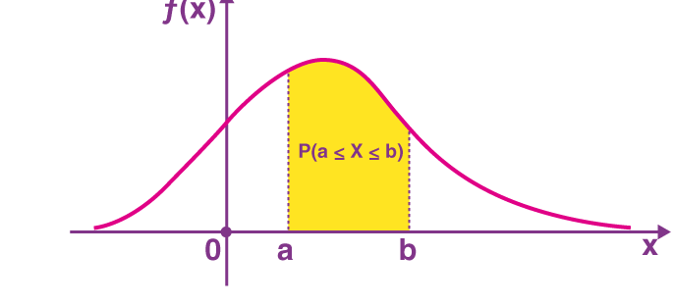

Probability Density Function Properties
Let x be the continuous random variable with density function f(x), and the probability density function should satisfy the following conditions:
- For a continuous random variable that takes some value between certain limits, say a and b, the PDF is calculated by finding the area under its curve and the X-axis within the lower limit (a) and upper limit (b).
- The probability density function is non-negative for all the possible values, i.e. f(x)≥ 0, for all x.
- The area between the density curve and horizontal X-axis is equal to 1,
- Due to the property of continuous random variables, the density function curve is continued for all over the given range. Also, this defines itself over a range of continuous values or the domain of the variable.

Applications of Probability Density Function
PDF, i.e. the probability density function has many applications in different fields of study such as statistics, science and engineering. Some of the important applications of the probability density function are listed below:
- In Statistics, it is used to calculate the probabilities associated with the random variables.
- The probability density function is used in modelling the annual data of atmospheric NOx temporal concentration
- It is used to model the diesel engine combustion.

